Project 4

Frederick Kelemen

2715308

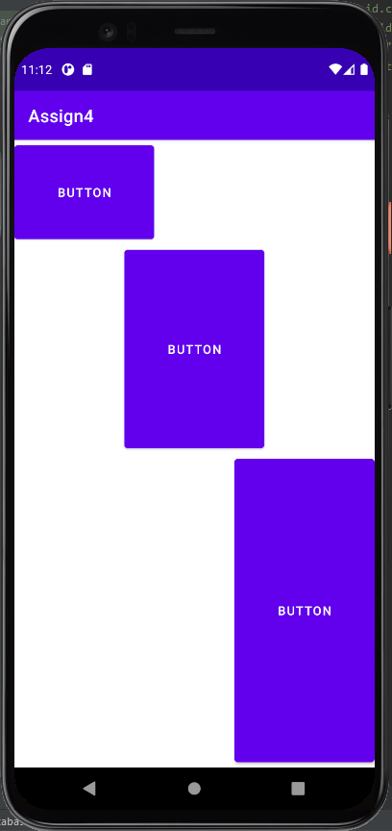Project 4 displays the use of LinearLayout and weight, the project shows three buttons with different weights and how they fill the display.